Hackathon Task: Ticketing System
Participant Requirements Specification
Build a small, working Kanban-style ticket tracker as a three-tier SPA backed by an RDBMS.
Mandatory scope: authentication, teams, epics, tickets, comments, and a draggable Kanban board.
Scrum, sprints, SSO, and advanced project-management features are explicitly out of scope.

1. Objective
Create a complete web application that allows registered users to organize work tickets by team and move them through a fixed Kanban workflow. The solution must demonstrate a functional user interface, server-side business logic, and persistent relational storage.

2. Required Architecture
- Single-page application (SPA) frontend.
- Backend application exposing an HTTP API.
- Relational database management system (RDBMS) for all persistent application data.
- Clear separation between presentation, application/API, and persistence tiers.
- The frontend and backend may be deployed as separate containers, or the backend may serve the compiled SPA, provided the three logical tiers remain clearly separated.
- Use a dedicated server-based RDBMS container such as PostgreSQL.
- Programming languages and frameworks are unrestricted. The application must be cross-platform.
- From a clean checkout, the complete solution must start from the repository root with `docker compose up --build`; no host-installed frontend, backend, or database runtime may be required beyond Docker Compose. The QA team must be able to run the application on a clean Windows, macOS, or Linux laptop.

3. User Accounts and Authentication
- Users can sign up using an email address and password. Email addresses are trimmed, compared case-insensitively, and must be unique.
- Users can log in and log out using local credentials. SSO and external identity providers are not required.
- Passwords must contain at least 8 characters, must never be stored in plain text, and must be hashed using an established password-hashing algorithm such as Argon2id.
- After sign-up, the system sends an email-verification message through a configurable SMTP service. The implementation must support relay1.dataart.com.
- A newly registered account cannot use the main application until the email address is verified.
- Verification links or tokens expire after 24 hours and are single-use. A successful verification leads the user to the login screen; automatic login is not required.
- An unverified user can request a new verification email from the login or verification-result screen. Issuing a new token invalidates earlier unused tokens.
- All business application screens and API endpoints require authentication, except sign-up, login, email verification, and verification-email resend. Static frontend assets and optional health/readiness endpoints may remain public.

4. Teams
- Tickets are grouped by team.
- Authenticated users can view the list of teams and create, rename, and delete teams.
- A team has at least: identifier, name, created timestamp, and modified timestamp.
- Team names must be non-empty after trimming and unique case-insensitively.
- A team cannot be deleted while it contains tickets or epics. The UI must show a clear validation message; cascading deletion of a team is not allowed.
- Team ownership and membership are not part of the mandatory scope. All verified users can view and manage all teams.

5. Epics
- Each epic belongs to exactly one team.
- The team is selected when the epic is created and cannot be changed later. Moving an epic between teams is out of scope.
- Provide a separate screen for epic CRUD operations: create, list, edit, and delete.
- An epic has at least: identifier, team reference, title, optional description, created timestamp, and modified timestamp.
- Epic titles must be non-empty after trimming.
- A ticket may optionally reference one epic, selected from a drop-down list.
- A ticket may reference only an epic that belongs to the same team as the ticket; the backend must enforce this relationship.
- An epic cannot be deleted while tickets reference it. The UI must show a clear validation message.

6. Tickets
Each ticket must contain the following fields:
Field | Required | Allowed values / type | Notes
ID | Yes | System-generated identifier | Stable and unique.
Team | Yes | Reference to a team | Determines the team board. Must reference an existing team.
Type | Yes | bug | feature | fix | Use exactly these three values. They are classification labels only; no different workflow behavior is required for bug, feature, or fix.
State | Yes | new | ready_for_implementation | in_progress | ready_for_acceptance | done | These are the canonical API values. The UI should display human-readable labels with spaces. The workflow is fixed; no custom states are required.
Epic | No | Reference to an epic | Selected from the epic list for the ticket’s team. Must be null or reference an epic from that same team.
Title | Yes | Text | Must be non-empty after trimming. It is intended as short display text, but no mandatory application-level maximum length is specified.
Body | Yes | Long text | Must be non-empty. Plain text or Markdown is acceptable; rich-text editing is not required. No mandatory application-level maximum length is specified.
Created at | Yes | Timestamp | Set by the server in UTC when the ticket is created.
Modified at | Yes | Timestamp | Set by the server in UTC whenever ticket fields or state change. Adding a comment does not change it.
Created by | Yes | Reference to user | Set automatically from the authenticated user.
Ticket operations:
- Create a ticket.
- Open and view all ticket fields, including created by, created at, and modified at.
- Edit ticket type, team, epic, title, body, and state.
- The modified timestamp represents the latest actual ticket field or state change. Saving unchanged values must not advance it.
- When a ticket’s team changes, the UI must clear or replace any selected epic. The backend must reject a ticket whose epic belongs to a different team.
- Delete a ticket after an explicit confirmation. Deleting a ticket also deletes its comments.
- State changes performed by drag-and-drop must be persisted immediately in the database.
- The backend must validate all submitted enum values and references; client-side validation alone is insufficient.

7. Comments
- Authenticated users can add comments to a ticket.
- A comment contains: identifier, ticket reference, author, body, and created timestamp.
- Comment bodies must be non-empty.
- Comments are displayed chronologically, oldest first.
- Adding a comment does not update the ticket modified timestamp and therefore does not change the ticket’s board ordering.
- Comments are immutable after creation for the mandatory scope. Editing and deleting comments may be implemented as stretch features.

8. Kanban Board
- The primary screen is a Kanban board for one selected team.
- The board contains exactly five columns, one for each ticket state, in workflow order.
- Each ticket is displayed as a card showing at least its title and type. Showing its epic is recommended.
- Users can drag a ticket card from one column to another. Dropping a card changes its state and persists the change through the backend API.
- If a drag-and-drop update fails, the card must return to its previous column and the UI must display an error.
- Cards may be moved directly between any two states; enforcing sequential transitions is not required.
- Within a column, cards are ordered by most recently modified first. Persisting a custom manual order is not required.
- The board must provide a clear way to create a ticket and open an existing ticket.
- At minimum, provide filtering by ticket type and epic, plus a case-insensitive substring search over ticket title. Active filters are combined using AND logic and may be implemented client-side or server-side.
- The interface must remain usable with at least 100 tickets on one team board.

9. API and Persistence Expectations
- All create, update, and delete operations must be performed through the backend API and persisted in the RDBMS.
- The application must not rely on browser local storage as the system of record.
- Use database constraints and/or server-side validation to maintain referential integrity.
- Return meaningful HTTP status codes and error messages for validation failures, authentication failures, missing records, and conflicts. Attempts to delete a team that contains tickets or epics, or an epic referenced by tickets, should return HTTP 409 Conflict.
- Identifiers may be UUIDs or database-generated numeric values. API timestamps must use an ISO-8601 representation in UTC.
- Cookie-based sessions or bearer-token authentication are both acceptable. Session identifiers, access tokens, and bearer tokens must not be placed in URLs. A single-use email-verification token may be included in the verification URL.
- Concurrent-edit conflict detection is not required; last successful write wins.
- Database schema creation must be automated through migrations or an equivalent repeatable initialization mechanism.
- After migrations or initialization complete, a fresh database must contain no application users, teams, epics, tickets, or comments. Migration metadata is allowed. The default startup path must not load sample or seed data; QA will create test data through the application UI or API.

10. Minimum Screens
- Sign-up screen.
- Email verification result screen.
- Verification-email resend action for unverified or expired-token cases.
- Login screen.
- Kanban board with team selector.
- Ticket create/edit/details view.
- Team management screen.
- Epic management screen.

11. Non-Functional Requirements
- Security: protect authenticated endpoints, hash passwords, validate input, and avoid exposing credentials or SMTP secrets in source control.
- Reliability: a browser refresh or application restart must not lose persisted data.
- Usability: display loading, empty, success, and error states where applicable.
- Compatibility: support a current desktop version of Chrome, Edge, or Firefox.
- Maintainability: include a README with prerequisites, configuration, startup commands.
- Testing: include automated tests covering at least one backend business flow and at least one frontend or API flow.

12. Explicitly Out of Scope
- Scrum functionality, sprints, backlogs, story points, velocity, burndown charts, or sprint planning.
- SSO, OAuth login, corporate identity integration, or social login.
- Fine-grained roles, administrators, team membership, private teams, or per-ticket access control.
- File attachments, notifications, mentions, watchers, audit history, and real-time multi-user updates.
- Custom workflows, custom ticket types, subtasks, dependencies, time tracking, and reporting dashboards.
- Production deployment, high availability, and production-grade mail infrastructure.

13. Definition of Done
- ☐ A user can sign up, receive a verification email through the configured SMTP service, verify the account, and log in.
- ☐ Teams and epics can be managed through the UI and persist in the database.
- ☐ A verified user can create, view, edit, and delete tickets.
- ☐ A user can add comments and see their author and timestamp.
- ☐ The Kanban board shows tickets in the correct state columns for the selected team.
- ☐ Dragging a ticket to another column updates the server and remains correct after refreshing the page.
- ☐ The application can be started from a clean checkout with `docker compose up --build` from the repository root.
- ☐ The solution contains no hard-coded user password or committed secret.
- ☐ A fresh database starts with schema and migration metadata only; no application data is preloaded.
- ☐ QA can create all required test or demo data through the application UI or API without manually changing database records.

14. Optional Stretch Features
- Password reset flow.
- Edit or delete own comments.
- Ticket activity history.
- Virtualized rendering for large boards.

15. Reference Wireframes
These low-fidelity wireframes illustrate the expected information hierarchy and primary user flows. They are not a required visual design: participants may use a different layout as long as all mandatory actions and states remain clear and usable. The collapsed user menu shown in the header is expected to include Log out. Disabled delete controls indicate records that cannot currently be deleted because they are referenced.
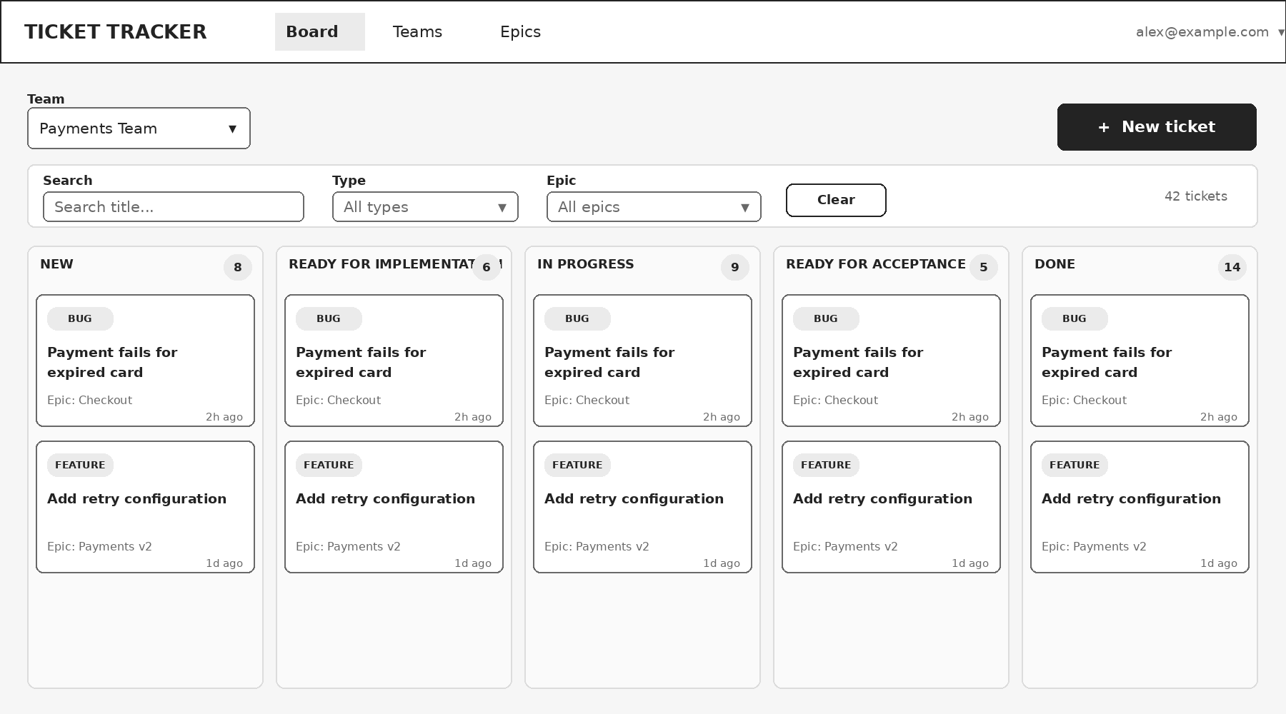
Wireframe 1 - Kanban board (primary screen)

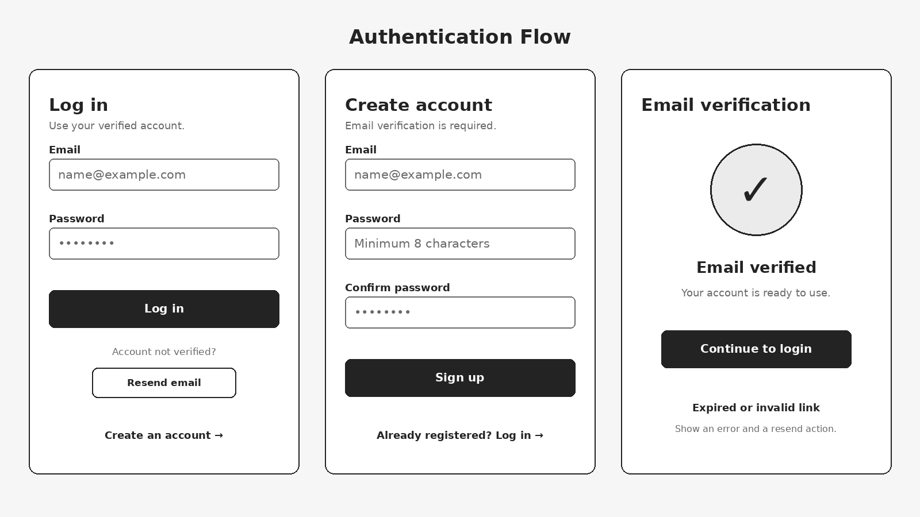
Wireframe 2 - Login, sign-up, and email verification
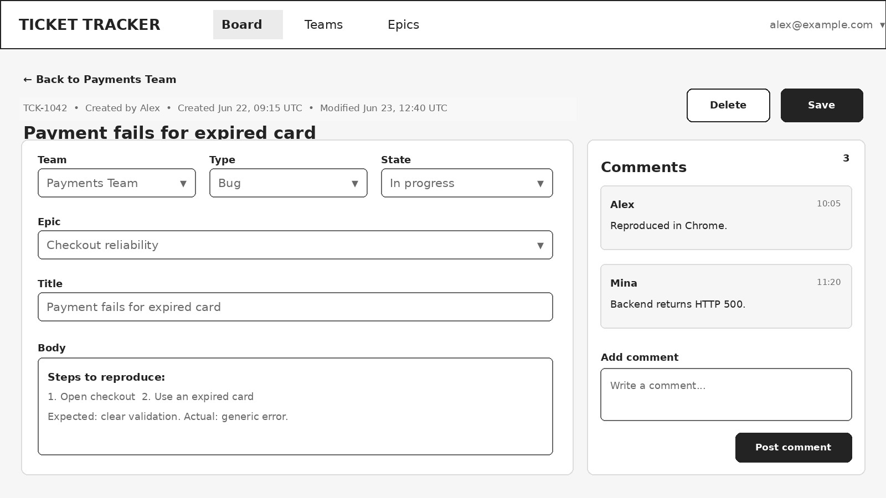
Wireframe 3 - Ticket details, editing, and comments

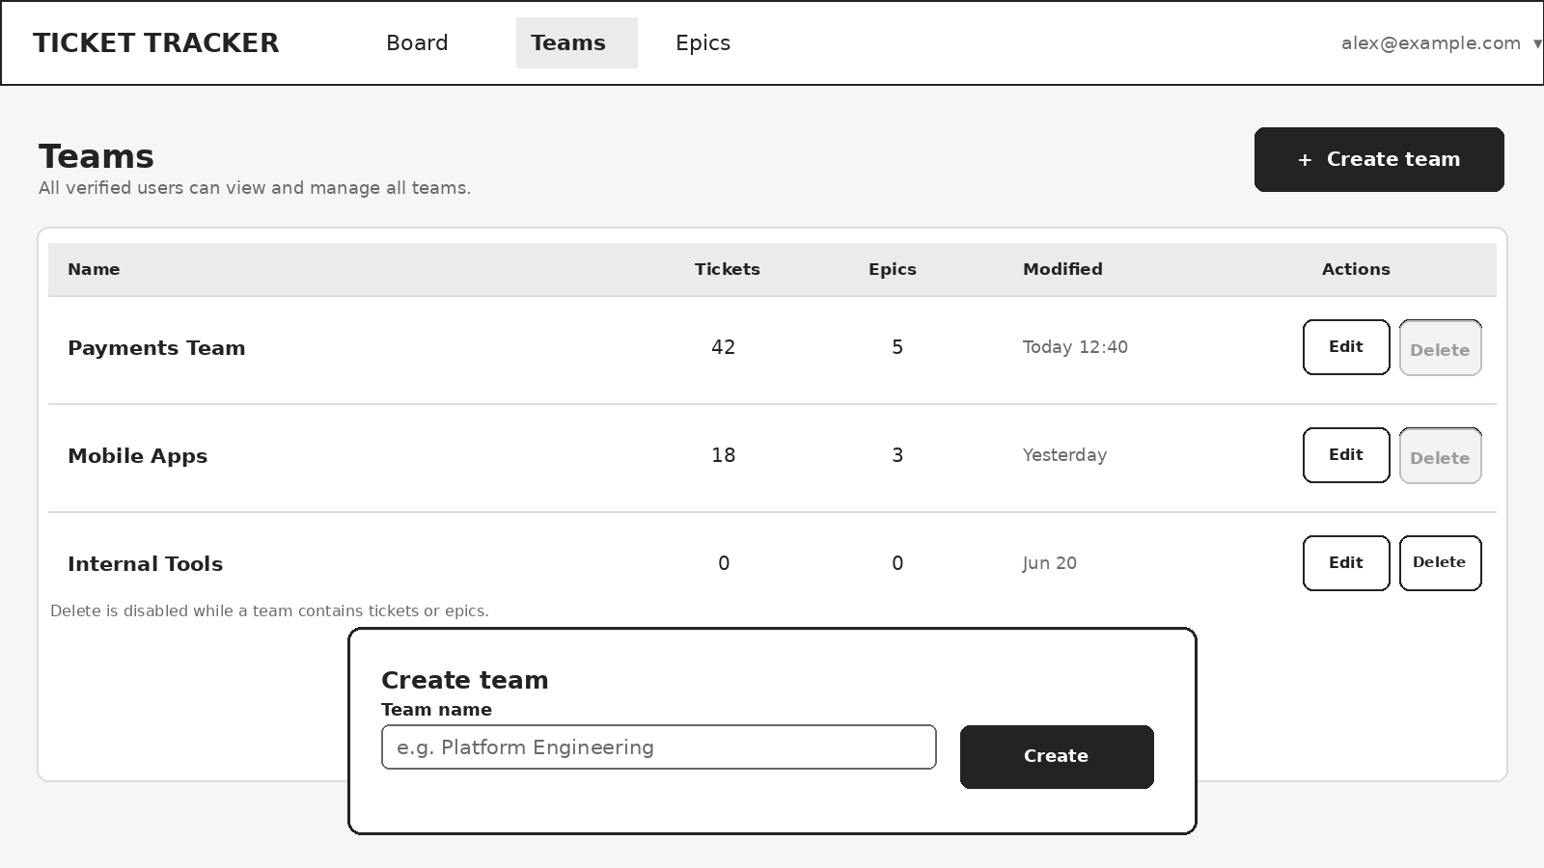
Wireframe 4 - Team management
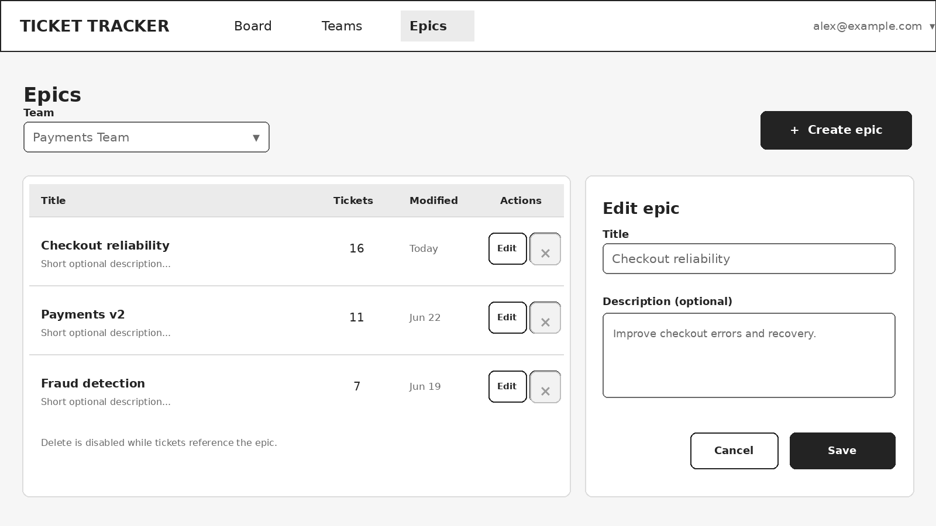
Wireframe 5 - Epic management

